Supporting Information
(Kim et al, Computational Generation and Screening of RNA Motifs in Large Nucleotide Sequence Pools, in preparation for NAR)

1. Supplemental Tables and Figures

Table S1. IBM Blue Gene machine run-time test results (hours).
Pool size  (#of seqs, 60nt) | Number of processors used
Pool size  (#of seqs, 60nt) | 10 | 100 | 1000
10⁹ | 1.192 | 0.121 | 0.019
10¹⁰ | - | 1.197 | 0.128
10¹¹ | - | - | 1.2
10¹² | - | - | 12
10¹³ | - | - | 120
10¹⁴ | - | - | 1200 (162*)
* Using NCSA linux cluster.

Table S2. Computational motif yields of aptamers using scanning and filtering. All results are scaled to 10¹² sequence pools with lengths of 40 nt (neomycin B and macugen), 60nt (ATP, chloramphenicol, streptomycin), and 100 nt (GTP) (mfe stands for minimal free energy structure). Yields from screening with suboptimal states within 0% (mfe), 5%, and 10% of mfe are shown.
Aptamer Motif | Suboptimal structures (%) | Computational Motif Hits Filtered by Tree Edit Distance |  |  |  | Experimentally Produced Motif Yields
Aptamer Motif | Suboptimal structures (%) | 6 | 12 | 18 | Unfiltered | Experimentally Produced Motif Yields
(a) Neomycin B | mfe | 339,243 | 538,129 | 576,615 | 579,790 | 1
(a) Neomycin B | 5% | 382,642 | 549,207 | 577,450 | 579,790 | 1
(a) Neomycin B | 10% | 403,716 | 557,476 | 578,390 | 579,790 | 1
(b) ATP† | mfe | 1,706 | 12,634 | 32,546 | 82,723 | 1000
(b) ATP† | 5% | 1,294 | 11,651 | 35,094 | 82,723 | 1000
(b) ATP† | 10% | 2,957 | 19,687 | 48,268 | 82,723 | 1000
(c) Chloramphenicol | mfe | 380 | 4,529 | 10,574 | 24,265 | 74
(c) Chloramphenicol | 5% | 671 | 6,874 | 13,620 | 24,265 | 74
(c) Chloramphenicol | 10% | 1,003 | 9,033 | 16,284 | 24,265 | 74
(d) Macugen* | mfe | 219,692 | 316,609 | 479,699 | 496,324 | 14.3
(d) Macugen* | 5% | 210,255 | 362,103 | 481,658 | 496,324 | 14.3
(d) Macugen* | 10% | 221,995 | 373,164 | 483,208 | 496,324 | 14.3
(e) Streptomycin** | mfe | 499 | 3,160 | 7,535 | 16,856 | 4.3
(e) Streptomycin** | 5% | 79 | 922 | 3,630 | 16,856 | 4.3
(e) Streptomycin** | 10% | 110 | 1,137 | 4,212 | 16,856 | 4.3
(f) GTP*** | mfe | 107 | 1,903 | 4,939 | 21,103 | 50
(f) GTP*** | 5% | 373 | 3,262 | 7,201 | 21,103 | 50
(f) GTP*** | 10% | 1,432 | 6,988 | 11,974 | 21,103 | 50
†added two single bases constraints. * added one single base constraints. ** added two base pair constraints. ***added four single bases constraints for minimal free energy (mfe) structure prediction.

Table S3. Computational shuffling results of aptamers (in Fig. 2). Note that all positions are randomly permutated and these shuffling procedures are iterated 1000 times and N is the number of sequences to have tree edit distance T among 1000 shuffled sequences.
(a) Neomycin B |  | (b) ATP |  | (c) Chloram. |  | (d) Macugen |  | (e) Streptomycin |  | (f) GTP
T | N | T | N | T | N | T | N | T | N | T | N
2 | 2 | 8 | 1 | 16 | 1 | 4 | 1 | 8 | 1 | 26 | 4
4 | 9 | 10 | 2 | 22 | 4 | 6 | 10 | 10 | 1 | 28 | 3
6 | 13 | 12 | 3 | 24 | 12 | 8 | 12 | 12 | 4 | 30 | 3
8 | 37 | 14 | 6 | 26 | 10 | 10 | 31 | 14 | 12 | 32 | 10
10 | 37 | 16 | 12 | 28 | 38 | 12 | 38 | 16 | 13 | 34 | 6
12 | 116 | 18 | 16 | 30 | 41 | 14 | 44 | 18 | 29 | 36 | 26
14 | 75 | 20 | 37 | 32 | 62 | 16 | 198 | 20 | 43 | 38 | 31
16 | 178 | 22 | 62 | 34 | 62 | 18 | 128 | 22 | 66 | 40 | 58
18 | 81 | 24 | 124 | 36 | 79 | 20 | 167 | 24 | 71 | 42 | 67
20 | 134 | 26 | 119 | 38 | 74 | 22 | 92 | 26 | 86 | 44 | 81
22 | 89 | 28 | 227 | 40 | 96 | 24 | 108 | 28 | 110 | 46 | 111
24 | 112 | 30 | 110 | 42 | 75 | 26 | 26 | 30 | 104 | 48 | 92
26 | 51 | 32 | 97 | 44 | 179 | 28 | 24 | 32 | 88 | 50 | 84
28 | 30 | 34 | 72 | 46 | 58 | 30 | 7 | 34 | 127 | 52 | 84
30 | 19 | 36 | 57 | 48 | 90 | 32 | 114 | 36 | 102 | 54 | 63
34 | 3 | 38 | 28 | 50 | 36 | Total | 1000 | 38 | 81 | 56 | 84
36 | 14 | 40 | 22 | 52 | 49 |  |  | 40 | 44 | 58 | 63
Total | 1000 | 42 | 3 | 54 | 17 |  |  | 42 | 10 | 60 | 49
 |  | 44 | 1 | 56 | 9 |  |  | 44 | 4 | 62 | 43
 |  | 46 | 1 | 58 | 3 |  |  | 46 | 2 | 64 | 25
 |  | Total | 1000 | 60 | 3 |  |  | 48 | 2 | 66 | 11
 |  |  |  | 62 | 1 |  |  | Total | 1000 | 68 | 1
 |  |  |  | 64 | 1 |  |  |  |  | 70 | 1
 |  |  |  | Total | 1000 |  |  |  |  | Total | 1000

Table S4. Flanking sequence analysis of five aptamers (a-e in Figure 2). Due to the partial structure in the extended flanking sequences, we used the structure Hamming distance (H) instead of tree edit distance for structural comparison between substructures without flanked sequences. We used filtered sequences (by T=6 and 12) in 10¹²-sized random pools in Table S1.
Aptamer | Flanking Seq. (L) | Tree Edit  Distance | Structural Hamming Distance Threshold (H)*
Aptamer | Flanking Seq. (L) | Tree Edit  Distance | 0 | ≤6 | ≤ 12 | ≤ 18 | Total
(a)Neomycin | 74 nt | T=6 | 12,128 | 169,724 | 308,748 | 338,660 | 339,243
(a)Neomycin | 74 nt | T=12 | 17,836 | 273,296 | 492,457 | 537,370 | 538,129
(b)ATP | 169 nt | T=6 | 0 | 169 | 971 | 1,617 | 1,706
(b)ATP | 169 nt | T=12 | 9 | 1,060 | 5,380 | 10,780 | 12,634
(c) Chloram. | 80 nt | T=6 | 6 | 196 | 326 | 370 | 380
(c) Chloram. | 80 nt | T=12 | 198 | 2,541 | 3,967 | 4,446 | 4,529
(d) Macugen | 30 nt | T=6 | 132,536 | 218,344 | 219,691 | 219,692 | 219,692
(d) Macugen | 30 nt | T=12 | 191,282 | 313,559 | 316,548 | 316,609 | 316,609
(e)Streptomycin | 74 nt | T=6 | 1 | 127 | 357 | 469 | 499
(e)Streptomycin | 74 nt | T=12 | 22 | 1,091 | 2,386 | 2,996 | 3,160
(f) GTP | 80 nt | T=6 | 17 | 82 | 101 | 102 | 107
(f) GTP | 80 nt | T=12 | 302 | 1,416 | 1,788 | 1,865 | 1,903
*H is the number of different symbols between two RNA structures represented as dot-bracket notations, where unpaired bases are noted as dot (".") and paired bases are noted as brackets, "(", for 5' end side and ")", for 3' end side.

Table S5. 3D structural analysis for neomycin B, ATP and streptomycin aptamers. The structures of wild type and candidate sequences are predicted using FARNA and MC-Sym tools. We align all atoms or binding pocket regions and calculated RMSD distance between experimental and predicted structures using CHARMM and Insight II. See Figure 5 for 3D structures.
Aptamer | Candidate | (T, H) | Method | Residue aligned | Residue compared | RMSD (Ǻ)
Neomycin B  (PDB:1NEM) | WT | (0, 0) | FARNA | 1-23 (whole sequence) | 1-23 | 3.12
 |  |  |  | 6-18 (binding pocket) | 6-18 | 2.49
Neomycin B  (PDB:1NEM) | WT | (0, 0) | MC-Sym | 1-23 | 1-23 | 3.60
 |  |  |  | 6-18 | 6-18 | 3.72
Neomycin B  (PDB:1NEM) | 1 | (6,0) | FARNA | 1-23 | 1-23 | 2.70
 |  |  |  | 6-18 | 6-18 | 2.40
Neomycin B  (PDB:1NEM) | 1 | (6,0) | MC-Sym | 1-23 | 1-23 | 4.65
 |  |  |  | 6-18 | 6-18 | 3.90
Neomycin B  (PDB:1NEM) | 2 | (6,0) | FARNA | 1-23 | 1-23 | 4.80
 |  |  |  | 6-18 | 6-18 | 4.17
Neomycin B  (PDB:1NEM) | 2 | (6,0) | MC-Sym | 1-23 | 1-23 | 3.33
 |  |  |  | 6-18 | 6-18 | 3.36
ATP  (PDD:1RAW) | WT | (0, 0) | FARNA | 1-36 | 1-36 | 5.86
ATP  (PDD:1RAW) | WT | (0, 0) | MC-Sym | 1-36 | 1-36 | 9.96
Streptomycin  (PDB:1NTA) | WT | (0,0) | FARNA | 1-44 | 1-44 | 11.61
Streptomycin  (PDB:1NTA) | WT | (0,0) | MC-Sym | 1-44 | 1-44 | 9.20
Sequences:
(a) Neomycin B aptamer wild type: GGACUGGGCGAGAAGUUUAGUCC
(b) Candidate 1: GGUGAGGGGGAUAACUUUUCGCC
(c) Candidate 2: CGGGCGGGCGUAUAGUUUGUCCG
(d) ATP aptamer wild type: GGGUUGGGAAGAAACUGUGGCACUUCGGUGCCAGCAACCC
(e) Streptomycin aptamer wild type: GGAUCGCAUUUGGACUUCUGCCUUUCGGCACCACGGUCGGAUC

Table S6. Computational shuffling results of the wild-type DSL and T80 ligases (in Fig. 3a). Note that all positions are randomly permutated, these shuffling procedures are iterated 1000 times, and N is the number of sequences to have tree edit distance T among 1000 shuffled sequences.
DSL Ligase |  | T80 Ligase
T | N | T | N
4 | 2 | 16 | 1
6 | 14 | 18 | 9
8 | 48 | 20 | 7
10 | 120 | 22 | 6
12 | 164 | 24 | 26
14 | 199 | 26 | 22
16 | 194 | 28 | 55
18 | 118 | 30 | 90
20 | 129 | 32 | 105
22 | 9 | 34 | 161
24 | 3 | 36 | 169
Total | 1000 | 38 | 128
 |  | 40 | 109
 |  | 42 | 53
 |  | 44 | 36
 |  | 46 | 17
 |  | 48 | 6
 |  | Total | 1000

Figure S1. Simple hypothetical motifs of RNA 2D structures, differentiated here into three groups (horizontally) on the basis of secondary structure, and within those groups on the basis of the different regions of sequences that are conserved within that particular motif. The yellow dots indicate the bases that we conserved.
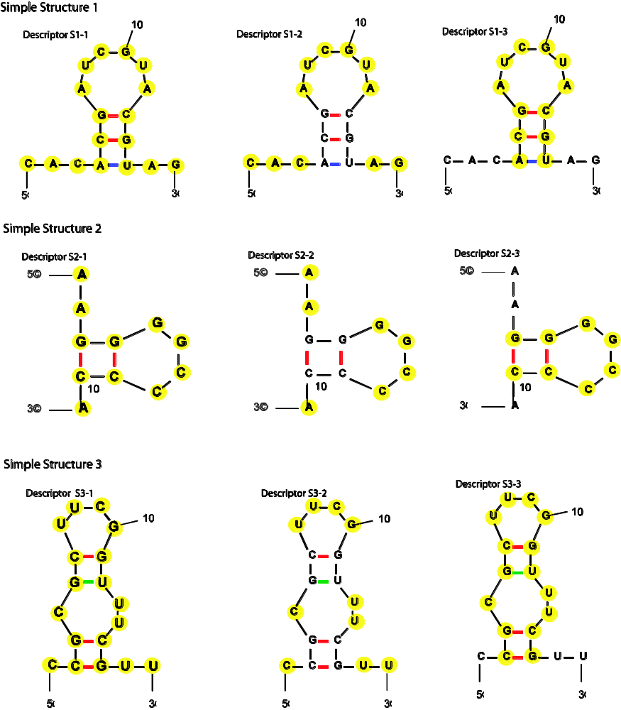

Figure S2. Computational and theoretical yields of simple motifs. All yields are scaled to correspond to a 10⁹ random sequence pool and normalized, (yield-mean/standard deviation). Each vertical rectangle here represents the motif yield for a specific descriptor (as shown in Figure S1). The black circles represent 10 computational motif yields from 10 different random pools. The red bar represents the spread of possible values within the normalized standard deviation (which is 1). The red and green asterisks represent the normalized mean value and the normalized theoretical motif yields in each case, respectively. See Table 2 for the actual (un-normalized) mean, standard deviation values and theoretical motif yields.
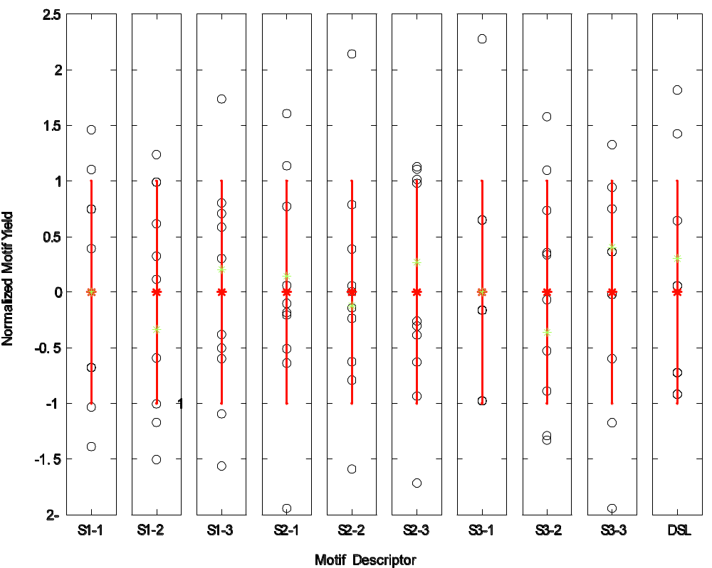

Figure S3. Structures of candidates for the GTP aptamer (as shown in Figure 2f) filtered by tree edit distance (T = 8, 12 and larger values) from target motifs. Note that the predicted structures with T=8 and 12 are similar with that of the selected GTP aptamer in Figure 2f, whereas other motifs with T=14, 18, and 24 are very different with that of the selected GTP aptamer.

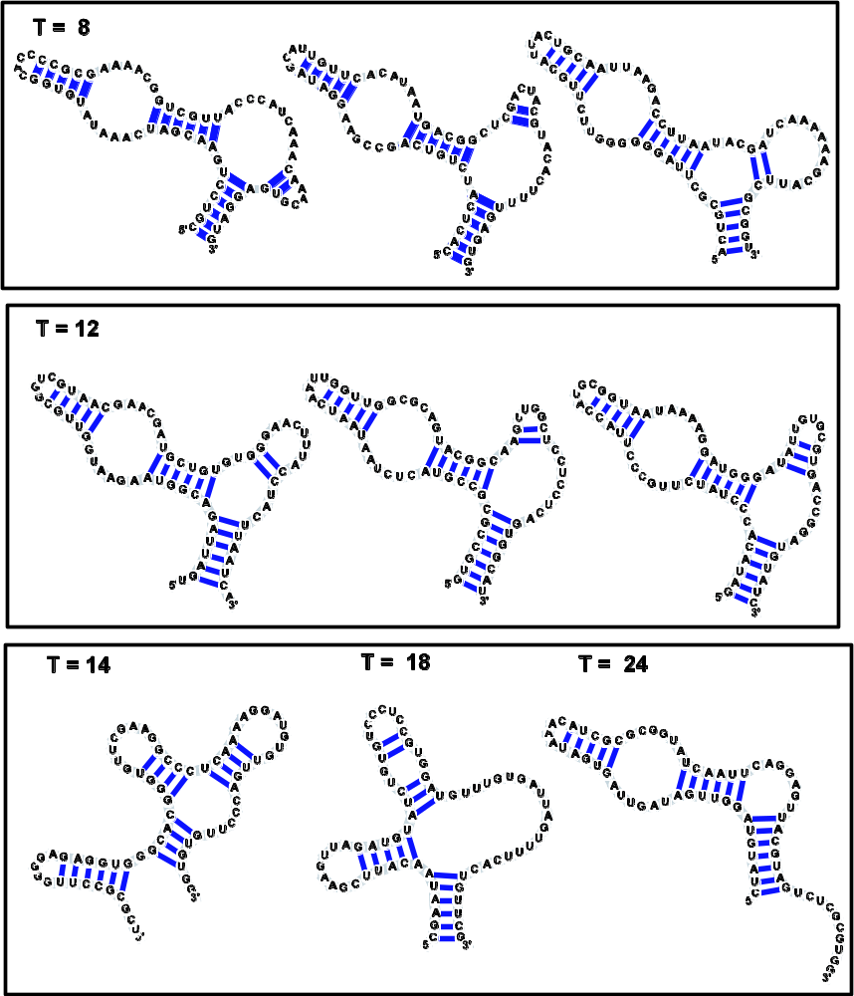

Figure S4. Schematic diagram of nucleotide transition probability matrix to search diverse regions of sequence space: (a) model of a pool generation procedure by a nucleotide transition probability matrix and (b) six classes of nucleotide transition probability matrices we used for designing pools to search distinct regions of sequence space. See Figure S5 for the 26 nucleotide transition probability matrices.

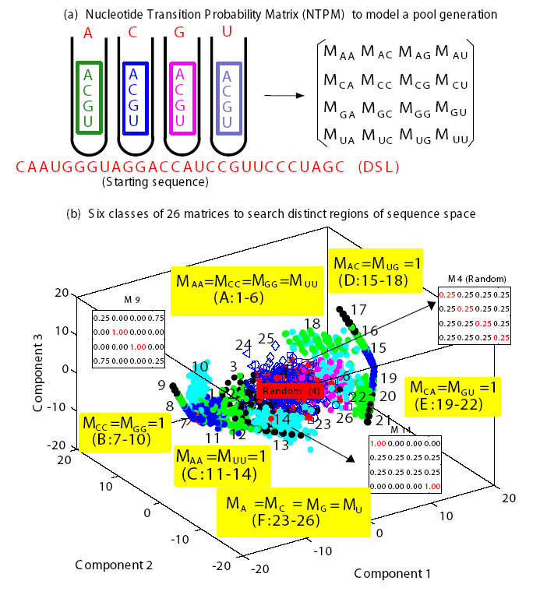

Figure S5. Our six classes of 26 nucleotide transition probability matrices for generating diverse sequence pools. The matrix classes are developed based on alteration of diagonal elements (class A) and covariance mutations (classes B-E), and equal rows (class F, which corresponds to pool generation with a fixed base composition). For pool synthesis using four vials, the nucleotide transition probability matrix is a 4x4 matrix specifying the molar fractions of nucleotide components A, C, G and U in the four vials. The columns represent the molar fraction of four bases in vial for each base denoted in each row.
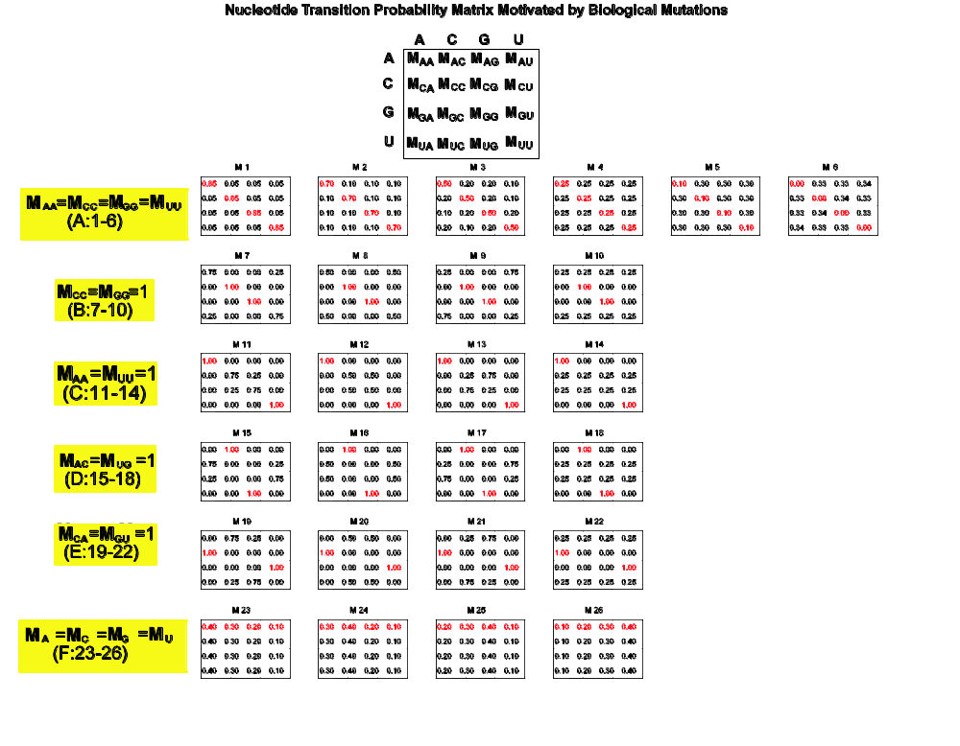

2. Motif Descriptors

Refer to http://casegroup.rutgers.edu/rnamotif.pdf (also Mäcke et al, NAR, 29:4724, 2001) for description of syntax and format of descriptors.

# Sim1.descr
# Each nucleotide is conserved.
parms
wc += gu; #Allow G-U base pairing
descr
ss(len=3,seq="CAC")
h5(len=3,seq="ACG")
ss(len=6,seq="AUCGUA")
h3(len=3,seq="CGU")
ss(len=2,seq="AG")

# Sim1_v2.descr
# Single strands are conserved.
parms
wc += gu; #Allow G-U base pairing
descr
ss(len=3,seq="CAC")
h5(len=3)
ss(len=6,seq="AUCGUA")
h3(len=3)
ss(len=2,seq="AG")

# Sim1_v3.descr
# Stem and loop are conserved.
parms
wc += gu; #Allow G-U base pairing
descr
ss(len=3)
h5(len=3,seq="ACG")
ss(len=6,seq="AUCGUA")
h3(len=3,seq="CGU")
ss(len=2)

# Sim2.descr
# Each nucleotide is conserved.
parms
wc += gu; #Allow G-U base pairing
descr
ss(len=2,seq="AA")
h5(len=2,seq="GG")
ss(len=4,seq="GGCC")
h3(len=2,seq="CC")
ss(len=1,seq="A")

# Sim2_v2.descr
# Single strands are conserved.
parms
wc += gu; #Allow G-U base pairing
descr
ss(len=2,seq="AA")
h5(len=2)
ss(len=4,seq="GGCC")
h3(len=2)
ss(len=1,seq="A")
# Sim2_v3.descr
# Conserve stem + loop
parms
wc += gu; #Allow G-U base pairing
descr
ss(len=2)
h5(len=2,seq="GG")
ss(len=4,seq="GGCC")
h3(len=2,seq="CC")
ss(len=1)

# Sim3.descr
# Each nucleotide is conserved.
parms
wc += gu; #Allow G-U base pairing
descr
ss(len=1,seq="C")
h5(len=2,seq="CG")
ss(len=1,seq="C")
h5(len=2,seq="GC")
ss(len=4,seq="UUCG")
h3(len=2,seq="GU")
ss(len=2,seq="UU")
h3(len=2,seq="CG")
ss(len=2,seq="UU")

# Sim3_v2.descr
# Single strands are conserved.
parms
wc += gu; #Allow G-U base pairing
descr
ss(len=1,seq="C")
h5(len=2)
ss(len=1,seq="C")
h5(len=2)
ss(len=4,seq="UUCG")
h3(len=2)
ss(len=2,seq="UU")
h3(len=2)
ss(len=2,seq="UU")

# Sim3_v3.descr
# Stems, bulges, and loop are conserved.
parms
wc += gu; #Allow G-U base pairing
descr
ss(len=1)
h5(len=2,seq="CG")
ss(len=1,seq="C")
h5(len=2,seq="GC")
ss(len=4,seq="UUCG")
h3(len=2,seq="GU")
ss(len=2,seq="UU")
h3(len=2,seq="CG")
ss(len=2)

# C8-ATP1.descr
# descriptor for consensus structure for aptamer to ATP as described by
# J. Szostak’s group, Nature 364:550-553 (1993)
parms
wc += gu; #Allow G-U base pairing
descr
h5( minlen=6, maxlen=14, pairfrac=0.8 )
ss( len=11, seq="ggaagaaacug", mismatch=2 )
h5( minlen=5, maxlen=12, pairfrac=0.8)
ss( minlen=3, maxlen=12 )
h3
ss( len=1, seq="g" )
h3

# chloramphenicol9.descr
# Descriptor file for chloramphenicol binding RNA aptamers as
# described in Burke et al, Chem. and Biol., 4:833-843 (1997).
parms
wc += gu; #Allow G-U base pairing
descr
h5( minlen=3, maxlen=7 )
ss( len=1, seq="a" )
h5( minlen=4, maxlen=6 )
ss( minlen=4, maxlen=6, seq="aaaa" )
h5( minlen=3, maxlen=8 )
ss( minlen=3, maxlen=26 )
h3
ss( len=1, seq="v" ) #"v" = a, c, or g
h3
ss( minlen=4, maxlen=6, seq="aaaa" )
h3

# neomycinB2.descr
# rnamotif descriptor for neomycin B, as described by
# Wallis et al, Chem. & Biol. 2:543-552 (1995) and
# D.J. Patel’s group, Structure, 7:817-827 (1999)
parms
wc += gu; #Allow G-U base pairing
descr
h5( minlen=7, maxlen=12, seq="gggs$", mispair=2 )
ss( len=1, seq="g" )
ss( len=4, seq="aaaa", mismatch=2 )
h3( seq="^suuu" )

#streptomycin3.descr
#rnamotif descriptor for streptomycin, as described by
#Wallace and Schroeder, RNA, 4:112-123 (1998) and
#D.J. Patel’s group, Chemistry & Biology, 10:175-187 (2003).
parms
wc += gu; #Allow G-U base pairing
descr
h5( minlen=4, maxlen=6 )
ss( minlen=5, maxlen=8, seq="gnannug" )
h5( minlen=3, maxlen=4 )
ss( len=3, seq="uun" )
h5( minlen=3, maxlen=12 )
ss( minlen=3, maxlen=26 )
h3
ss( minlen=3, maxlen=5, seq="ncncg" )
h3
ss( minlen=1, maxlen=2 )
h3

# GTP-9-4.descr
# descriptor for informationally complex motif for aptamer to GTP as described by
# J. Szostak's group, JACS 126:5130-5137 (2004)
# seq: nothing
parms
wc += gu; #Allow G-U base pairing
descr
h5( len=6)
ss( len=1)
h5( len=6)
ss( len=6)
h5( len=5)
ss( len=4)
h3
ss( len=6)
h3
ss( len=3)
h5( len=2)
ss( len=11)
h3
h3

# Macugen descriptor Using Rules Based on 2'-Fluropyrimidine Paper # Ruckman et al, J. Biol. Chem., 273:20556-20567 (1998)
parms
wc += gu; #Allow G-U base pairing
descr
h5(minlen=3,maxlen=5,seq="a$")
ss(len=4, seq="auca")
h5(minlen=3,maxlen=4)
ss(len=4,seq="nunn")
h3
ss(len=3,seq="ann")
h3

# Ligase_dsl_v1.descr
# Consensus Sequence described by
# Ikawa et al, PNAS, 101:13750-13755 (2004)
parms
wc += gu;

descr
ss (len=4, seq="caan")
h5 (len=3, seq="ggg")
ss (len=2, seq="ua")
h5 (len=2)
ss (len=5)
h3 (len=2)
ss (len=3, seq="guu")
h3 (len=3, seq="ccc")
ss (len=4)

# Ligase_t80_v6.descr
# Consensus sequence described by
# Voytek and Joyce, PNAS, 104:15288-15293 (2007)
parms
wc += gu;

descr
ss(len=4, seq="caan")
h5(len=3, seq="ggg")
ss(len=2, seq="ua")
h5(len=2)
ss(len=1)
h5(len=2)
ss(len=8)
h3
ss(len=1)
h5(len=4)
ss(len=6)
h3
ss(len=1)
h3(len=2)
ss(len=3, seq="guu")
h3 (len=3, seq="ccc")
ss(len=4)

